Princess Sumaya University for Technology - King Hussein School for Computing Sciences
CS11253 - Object Oriented Programming Lab - Spring 2024
Project

In this project, you will implement a system that creates and manipulates a set of Movies. There are two types of Movies in our system: Sci_Fi Movies and Action Movies.
Consider the following UML class diagram. The Movie class is the parent, while the Sci_Fi and Action classes are the children.

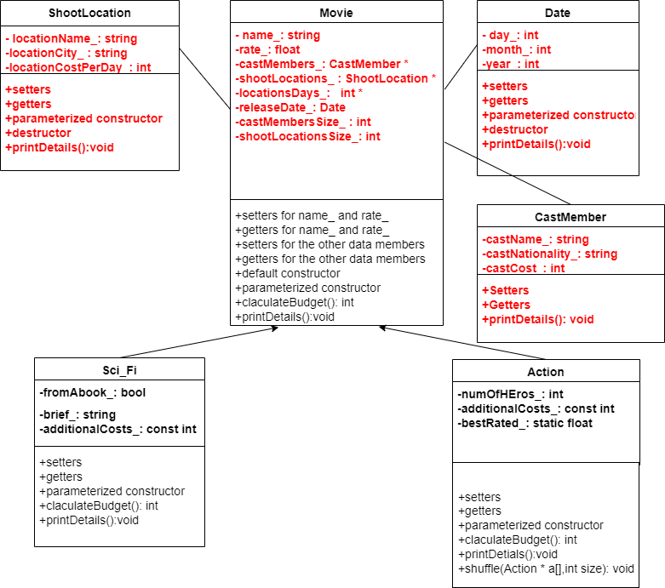

Note: you will not implement the Date class, it is given to you with the question
Question 1: Implement the CastMember class and the ShootLocation class. You should make any function that can be defined as constant, constant.

Question 2: Implement the Movie class, you should separate the header from implementation and write your code in Movie.h and Movie.cpp.

Movie Class

- Every movie has a name_(string) and a rate_(float).

- Every movie has many shootLocations_(مواقع التصوير), which is an array of ShootLocations objects. shootLocations_ is an array of ShootLocations objects, where each movie has many ShootLocations (مواقع التصوير).

- The size of the shootLocations_ array is stored in shootLocationsSize_.

- Every movie has many castMemebrs_(الممثلين), which is an array of CastMembers. castMemebrs_ is an array of CastMembers objects, where each movie has many castMemebrs (الممثلين)

- The size of the castMemebrs_ array is stored in castMemebrsSize_.

- Each movie has one releaseDate_(تاريخ الاصدار) of type Date.

- locationDays_ is an array of integers that stores the number of days for every shoot location. For example, if the first location in the ShootLocations_ array was used for 10 days, the first entry in the locationDays is 10, and so on.

- The size of locationDays_ equals the size of shootLocations_, which is stored in shootLocationsSize_.

- Write the default constructor to initialize the data members with proper default values.
- Write setters for all data members.
- Write getters for all data members.

- Write a parameterized constructor that receives value for all data members as follows.
Movie(string name, float rate, Date d, CastMember* CS, ShootLocation* SL, int* LD, int castsize, int locationsize)

- The calculateBudget has no implementation in the movie class, yet it has a different implementation in Sci_fi, and Action classes. The calculateBudget is a pure virtual function that has no implementation in the movie class.

- printDetails is a virtual function that prints all the information of the movie. It should call the printDetails function from the classes ShootLocation, Date, and CastMember.

Question 3: Implement the Sci_Fi class.
Class Sci_Fi

- Do not separate the header from the implementation; write all the code in Sci_Fi.cpp.

- The Sci_Fi class inherits from the Movie class.

- The Sci_Fi class contains three data members: fromAbook_ (bool), brief_ (string), additionalCost_ (int).

- The additionalCost_ in Sci_Fi class is a constant integer and its value is 90000.

- Write a parameterized constructor that receives values for all data members except additionalCost_ , as follows.

Sci_Fi(bool fromAbook, string brief_,string name, float rate, Date d, CastMember* CS, ShootLocation* SL, int* LD, int castsize, int locationsize)

- The print function in Sci-Fi will print all the information of the Sci_Fi class and it should call the printDetails function from the Movie Class.

- The calculateBudget() should return the total budget which equals the additional cost plus the original cost. The additional cost is stored in the additionalCosts_ data member.
The original cost equals the sum of the cost of all the cast members plus the cost of all shoot locations.
The cost for each cast member of the movie is stored in the castCost_ data member in the CastMember class.
The cost for each shoot location can be calculated by multiplying the
LocationCostPerday_ (تكلفة حجز المكان ليوم واحد) in the ShootLocation Class by the number of days which is stored in the LocationsDays_ array.

Question4: Implement the Action class.
Action Class

- Do not separate the header from implementation; write all the code in Action.cpp.

- The Action class inherits from Movie.

- The Action Class contains three data members: numberOfHeros_(int), bestRated_(float), additionalCost_ (int).

- The Additional cost in Action class is a constant integer and its value is 70000.

- The bestRated data member is a static data member and its initial value is 0. Its value should equal the highest rate of all Action movies objects.

- Write setters and getters for numOfHeros_. there are no validation rules for this data member.

- Write a parameterized constructor that receives values for all data members, as follows.

Action(int numOfHeros, string name, float rate, Date d, CastMember* CS, ShootLocation* SL, int* LD, int castsize, int locationsize)

- The calculateBudget() should return the total budget which equals the additional cost plus the original cost. The additional cost is stored in the additionalCosts_ data member.
The original cost equals the sum of the cost of all shoot locations.
The cost for each shoot location can be calculated by multiplying the
LocationCostPerday_ (تكلفة حجز المكان ليوم واحد) in the ShootLocation Class by the number of days which is stored in the LocationsDays_ array.

- Define a void function called shuffle, the function receives an array of Action pointers with its size. The function should apply the following for each pointer.
- Shuffle the castMemebrs_ array, which means to change the order of the elements in the array randomly.
- Shuffle the shootLocations_ array and LocationsDays_array , which means to change the order of the elements in the arrays randomly, make sure that the data is still consistent. For example, if the shootLocation that was at index 0 before the shuffling, become at index 4 after shuffling then the locationDays_ element that was at index 0 before the shuffling should also become at index 4 after shuffling.

Question 5:
main
- Create an array of two Movie pointers.
- The first pointer should point to an Action movie object (you can make it in the stack or in the heap). The information in the object is from your choice.
- The second pointer should point to a Sci_Fi movie object (you can make it in the stack or in the heap). The information in the object is from your choice.

